**UNIVERSITY OF MONTENEGRO, FACULTY OF PHILOSOPHY IN NIKŠIĆ, SOCIOLOGY STUDY PROGRAM**

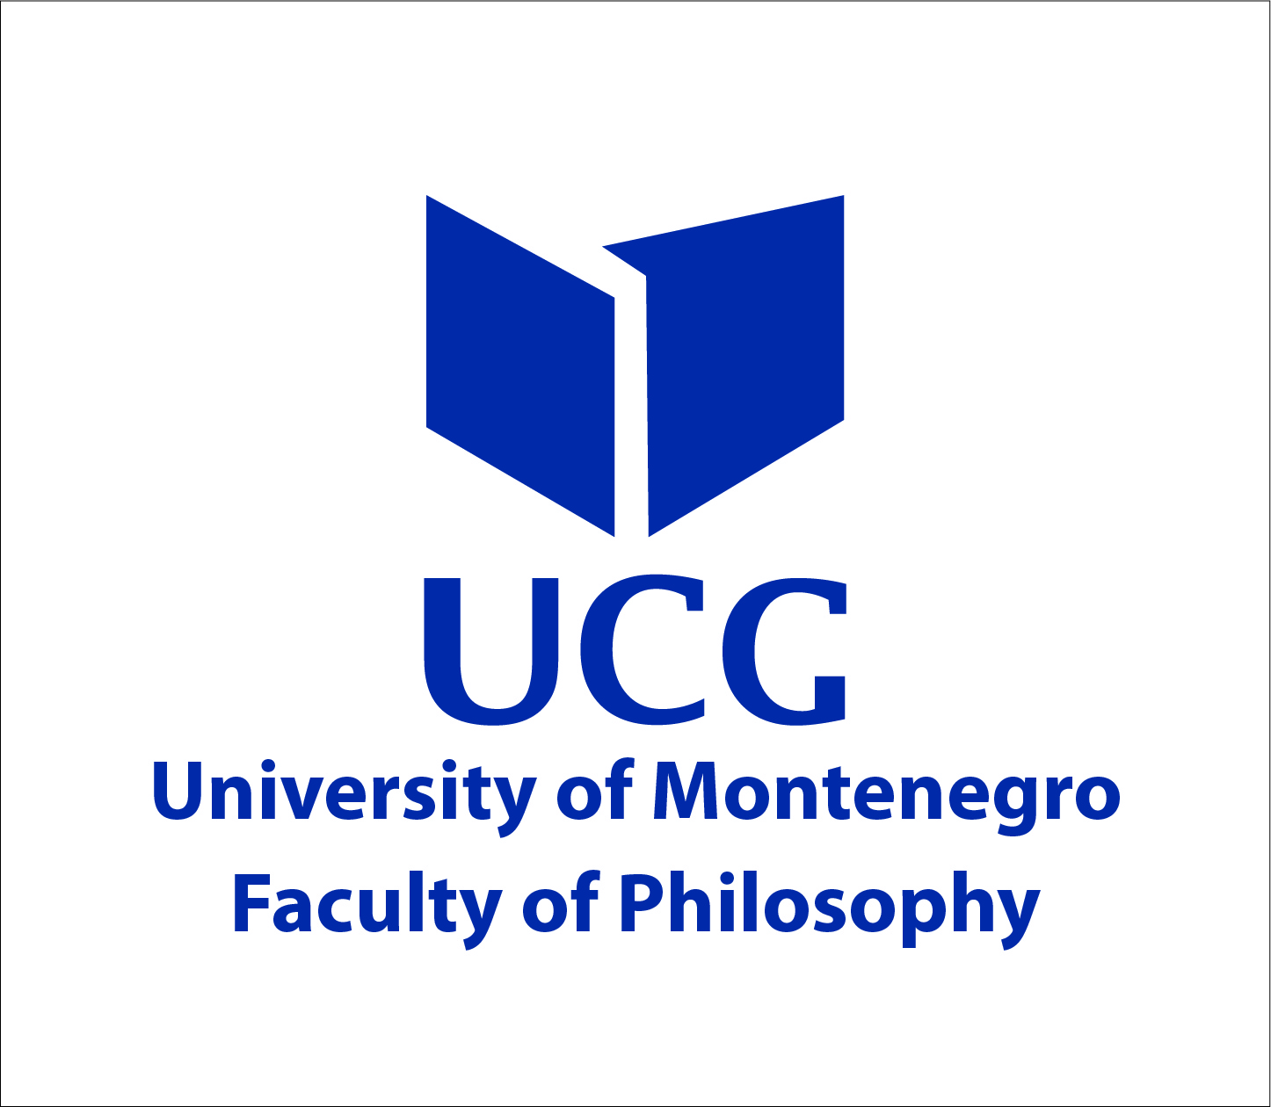

MEDITERRANEAN ASSOCIATION FOR SOCIOLOGY OF TOURISM; STUDY PROGRAM FOR SOCIOLOGY AND ECONOMIC LAW, UNIVERSITY OF BOLOGNA; TOURISM RESEARCH CENTER, UNIVERSITY OF CALABRIA; FACULTY OF PHILOSOPHY IN OSIJEK; FACULTY OF PHILOSOPHY IN NIŠ; FACULTY OF POLITICAL SCIENCES IN BANJA LUKA; UNESCO CHAIR IN EDUCATION FOR DEMOCRATIC CITIZENSHIP AND HUMAN RIGHTS

** **

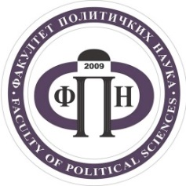

**ARE INVITING YOU TO THE**

**INTERNATIONAL CONFERENCE**

Dedicated to Professor Ratko R. Božović

*Faculty of Philosophy Nikšić, Montenegro, 29. May 2020.*

**SOCIOLOGY, PHILOSOPHICAL AND SCIENTIFIC KNOWLEDGE FOR THE BETTERMENT OF HUMANITY**

**Scientific Committee**: Slobodan Vukićević (University of Montenegro), Vladimir Zyryanov (Moscow University Lomonosov), Zinaida Golenkova (Russian Academy of Science), Zoran Vidojević (Institut of Social Sciences Belgrade), Dragoljub - Brka Đorđević (University of Niš), Borislav Đukanović (University of Montenegro), Tullio Romita (University of Calabria), Gabriele Manella (University of Bologna), Natalija Jovanović (University of Niš), Željko Pavić (University of Osijek ), Nemanja Đukić (University of Banja Luka), Bojka Đukanović (University of Montenegro)

**Organizational Committee**: Goran Barović (University of Montenegro), Nataša Krivokapić (University of Montenegro), Rade Šarović (University of Montenegro), Goran Ćeranić (University of Montenegro), Predrag Živković (University of Montenegro), Vladimir Bakrač (University of Montenegro), Dragan Todorović (University of Niš)

**Conference Sessions:**

I The interdisciplinarity of philosophical and scientific knowledge

- Philosophical understanding of trends, risks and development opportunities of societies

- Sociological theories and society studying practice

- Society as a subject of historical science

- Political concepts and studies of society

- Cultural and anthropological aspects of social development

- Experience in interdisciplinary analysis of societies and communities

II Specific comparative sociological research of Montenegrin and other societies

- Comparative studies focusing on specific societies

- Former USSR and SFRY countries: societal trajectories, similarities and differences in integration and disintegration processes

III Sociological research on Montenegro’s multicultural society, other societies and their reflections in social practice:

- Social structure and social system

- Family: discussion and practice

- The idea of ​​government, contemporary institutions and politics

- Multicultural and intercultural character of Montenegrin society in sociological research

- Contemporary cultural practices in the globalization and localization trends

- Work and entrepreneurship

- The culture of need and social change

- Education in Sociological Vision: New Quality and Role

- Social awareness and values ​​foundations of the modern society (religion, morality, humanity)

- Inequalities in contemporary societies: Sociological meaning and interpretation

- Sociological media research, digital reality of society: practice, perspectives, contradictions

- Sociological surveys of the city and the countryside

- Montenegro - an ecological state

- Tourism as a sociological phenomenon

- Nutrition Sociology: From Gastronomic Tourism to Foodsharing

- Sociological Youth Studies

- Everyday life in sociological research

Those interested in attending the conference should e-mail their abstracts in English, using the Submission Form. The abstracts, of up to 2,500 characters, are to be sent by March 23, 2020, to the email address of the conference coordinator Nataša Krivokapić: [natasa.kr@ucg.ac.me](mailto:natasa.kr@ucg.ac.me)

Participants will receive an abstract acceptance e-mail by March 30, 2020.

The conference enables the following forms of participation: plenary, oral presentation, poster presentation and non-presentation.

The conference languages are Montenegrin / Serbian / Croatian / Bosnian and English.

In order to participate in the conference, participants shall be requested to pay a registration fee of 50 €. The fee includes conference materials, a certificate, a book of abstracts and paper publication in the journal Sociološka luča. Masters and doctoral students are entitled to the registration fee of 20 € (also payable upon arrival to the conference). Participants are invited to send a copy of the registration fee payment slip by May 1 to one of the following e-mail addresses: [rades@ucg.ac.me](mailto:rades@ucg.ac.me) or [natasa.kr@ucg.ac.me](mailto:natasa.kr@ucg.ac.me)

Participants from outside of Montenegro can pay the conference fee using the following instructions:

Recipient: UNIVERSITY OF MONTENEGRO

FACULTY OF PHILOSOPHY NIKSIC

Name of Bank: Montenegrin Commercial Bank Podgorica

IBAN 25510000000000014008

SWIFT ADDRESS: CKBCMEPG

VAT 02016702

Participants from Montenegro can pay the conference fee by using the Faculty of Philosophy’s bank account: 510-188-58

Participants can send their full papers, no later than October 1, 2020 to the following e-mail address [natasa.kr@ucg.ac.me](mailto:natasa.kr@ucg.ac.me)

The papers accepted shall be published in the journal Sociološka luča [www.socioloskaluca@ac.me](http://www.socioloskaluca@ac.me) (the instructions for authors can be found on the journal’s website).

**SUBMISSION FORM**

Submission Deadline **March 23, 2020**

|  |  |
| --- | --- |
| Name and Surname of Author/s |  |
| Address |  |
| Institution |  |
| E –mail address |  |
| Phone number |  |
| Title of paper |  |
| Abstract (up to 2500 characters) |  |

To be sent to: [natasa.kr@ucg.ac.me](mailto:natasa.kr@ucg.ac.me)